**Short Question Answers:**

Q1 - What is a condition-controlled loop?

A “While loop” is usually referred to as condition-controlled loop. It’s called condition-controlled loop because it will be executed if the condition is true, and if the condition is false, then it will not be executed.

Q2 - What is an infinite loop? Write the code for an infinite loop.

A – A loop which never ends and continue to execute is called an infinite loop.

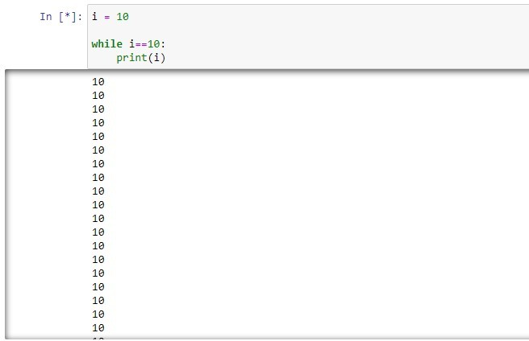

Q3 - Why is it critical that accumulator variables are properly initialized?

A - The variable that is used to accumulate the total of the numbers is called an accumulator. When the loop finishes, the accumulator will contain the total of the numbers that were read by the loop.

If the accumulator starts with any value other than 0, it will not contain the correct total when the loop finishes.

Q4 - What is the advantage of using a sentinel?

A - When processing a long sequence of values with a loop, a better technique is to use a sentinel. A sentinel is a special value that marks the end of a sequence of items. When a program reads the sentinel value, it knows it has reached the end of the sequence, so the loop terminates.

Q5 - How would you process a long sequence of values with a loop, using a sentinel?

A – Consider Alan wants to calculate the tax of items. In this process Alan will create a loop that asks him to enter the value of the item to calculate the tax rate. In this process Alan will also use a sentinel to stop the execution of the loop (if he wants to). He knows that if he doesn’t do it the loop will not be terminated. So, in order to control the execution of the loop, Alan will use a sentinel.

Q6 - What does the phrase “garbage in, garbage out” mean?

A - “garbage in, garbage out.” Its sometimes abbreviated as GIGO. It refers to the fact that computers cannot tell the difference between good data and bad data. If a user provides bad data as input to a program, the program will process that bad data and, as a result, will produce bad data as output. So, it’s the job of the programmer to make sure that the program is well prepared.

Q7 - Differentiate between nested loops and normal loops.

A –

Nested Loop:

A loop that is inside another loop is called a nested loop. A nested loop is a loop that is inside another loop. In book page 170, a clock mentioned as a good example of a nested loop.

Normal Loop:

A normal loop is a program that repeat itself as long as the condition is true. It maybe infinite loop.